**1) Project Title; Students in the team.**

Group Members: Shamaamah Ahmad, Jianming Liu, Harry Newman, Jeremy Huml

**2) Statement of the problem: one paragraph explaining the problem you want to solve.**

For our project, we are developing a warehouse management system that keeps track of inventory. For our regular customers, we don't need to keep track of them since they do not have an account. We track purchases with customer data. When you start the program, there’s an option to be from the customer’s perspective, or the manager's. As a customer, you will be able to choose from a main menu to login. As a manager, you will be able to replenish stock, and see sales reports. Our classes will include: customer main menu, customer database, manager controls, and inventory The customer main menu class will consist of stock availability, purchase, access to customer accounts, and logging out. The customer database class will store all information that is relevant to the customer like their transaction history and most frequently bought items. The inventory class will have an array with the names of the products and the quantity of them. This will be the main database of knowing what is in stock that customers will be able to access. The manager controls class will be able to restock all items in the inventory, have a sales report of total sales and sales from each customer, and be able to access customer account information in order to see their purchase history. We are trying to make an inventory system that helps smoothie make purchases.

**3) Background Research: Brief review of available solutions.**

Warehouse management systems have been around for decades and have evolved significantly over the years. These systems are designed to help businesses efficiently manage their inventory, track sales, and improve customer service. There are many different solutions available in the market, ranging from small, simple systems to large, complex ones used by multinational corporations. One popular solution for warehouse management is SAP Warehouse Management. This system is part of the SAP ERP system and offers a range of features for managing inventory, including inventory tracking, stock replenishment, and order fulfillment. The system is highly customizable and can be tailored to meet the specific needs of businesses in various industries. Another popular solution is Microsoft Dynamics 365 for Finance and Operations. Smaller businesses may opt for simpler solutions like QuickBooks or Xero. These accounting software programs offer basic inventory management features like tracking product quantities and generating purchase orders. While these systems may not have the advanced features of larger systems, they can be a cost-effective option for small businesses. These are some commercial based solutions.

**4) Design solution: Identify and define UML diagrams for the classes, and how the classes interact (composition, inheritance).**

**Shamaamah Ahmad**

| Inventory |
| --- |
| * products: String[][] |
| * Inventory() * addItem(name: String, price: double, quantity: int): void * removeItem(name: String): void * updateItem(name: String, price: double, quantity: int): void * getItem(name: String): String[] * displayInventory(): void * readProductsFromFile(): void * writeProductsToFile(): void * groupProductsToFile(): void * getProducts(): ArrayList<String[]> |

**Jianming Liu**

| ManagerControls |
| --- |
| * String[ ] [ ] userDataArray[]: |
| * businessReport(customer: Array): void * salesReport(name: String): void * replenishItems(): void |

**Harry Newman**

| Login |
| --- |
| -userDataArr : String[][] |
| +addAccount(data: String): void  +userData(data: String): String[][]  +userData(): void  +createAccount(): void |

**Harry Newman**

| MainMenu |
| --- |
| -login: Login  -username: String |
| +MainMenu(username: String)  +CustomerMenu(): void  +ManagerMenu(): void  +MainMenuSetup(): void |

**Jeremy Huml**

| CustomerDatabase |
| --- |
| -customerArray: Customer[] |
| +addAccount(id: int, name: string): void  +removeAccount(id: int): void  +getAccount(id: int): Customer |

**Jeremy Huml**

| Customer |
| --- |
| -id: int  -name: string  -transactions: string[] |
| +Customer()  +Customer(int, string)  +getID(): int  +setID(id: int): void  +getName(): string  +setName(name: string): void  +getTransaction(id: int): string  +addTransaction(transaction: string): void |

**5) Built and Test a Prototype: Write the code that implements the design solution and test it.**

**You can attach a printout of the code as well as screen shots illustrating the use of the**

**program in the Appendix. CHECK APPENDIX**

**6) User’s guide: explain briefly how to use the program.**

Welcome to our warehouse management system. This program is designed to help businesses efficiently manage their inventory, track sales, and improve customer service. Here's a brief guide on how to use the program:

Starting the Program:

When you start the program, you'll be given the option to log in as a customer or a manager. Choose the option that applies to you.

Customer Main Menu:

If you log in as a customer, you'll be taken to the main menu. Here, you can choose from several options, including:

Stock Availability: This option allows you to check if a particular item is in stock or not.

Make a Purchase: This option allows you to make a purchase by selecting items from the inventory and adding them to your cart.

Return an Item: This option allows you to return an item that you previously purchased.

Access Account History: This option allows you to view your purchase history and account details.

Log Out: This option allows you to log out of the program.

Manager Controls:

If you log in as a manager, you'll be taken to the manager controls. Here, you can choose from several options, including:

Replenish Stock: This option allows you to restock items that are running low.

Sales Report: This option allows you to view sales reports for a particular time period, including total sales and sales from each customer.

Access Customer Accounts: This option allows you to view customer account information, including purchase history and account details.

Log Out: This option allows you to log out of the program.

Inventory:

The inventory class has an array with the names of the products and the quantity of them. This is the main database of knowing what is in stock that customers will be able to access. As a customer, you can check the availability of a particular item before making a purchase. As a manager, you can replenish stock and manage inventory levels.

With these simple steps, you can use our warehouse management system to efficiently manage your inventory, track sales, and improve customer service.

**7) Reflection:**

**a. Which concepts learned in class were helpful for the project?**

Object-Oriented Programming (OOP), File Input/Output, Data Structures, User Interface (UI) Design, and Testing.

**b. Which new concepts you learned on your own?**

Graphic User Interface was one feature that had to be learned outside of the classroom.

**c. How would you expand the project in the future?**

If the project grows larger, we may want to consider using a database management system to store data. Another way to expand is by adding security. Security is an important aspect of any software project. We could implement user authentication and authorization to restrict access to certain parts of the program. Also, we could add encryption to protect sensitive data like customer information and transaction history. Other ways include adding data analytics and a mobile application.We could use data analytics techniques to gain insights into customer behavior and sales trends. This could involve using data visualization tools to create charts and graphs. For the mobile app, it can make our system more accessible for customers and managers on the go.

**d. Which part was the most difficult to develop and implement?**

Designing a user-friendly interface, managing inventory and stock levels, and creating methods to comfortably interact with each class.

**8) Contributions: List contributions by different members of the team.**

Shamaamah Ahmad: Project Report, Inventory Class

Jianming Liu: GUI implementation, ManagerControls Class

Harry Newman: GUI implementation, Login Class, MainMenu Class

Jeremy Huml: CustomerDatabase Class, Customer Class

**9) APPENDIX (CODE)**

cart.txt

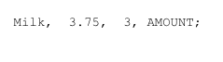

inventory.txt

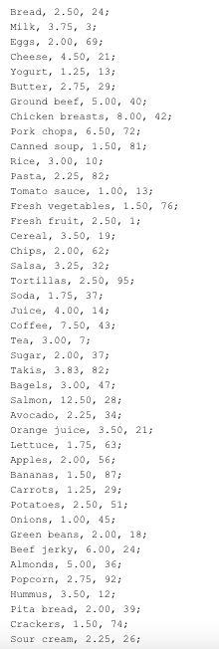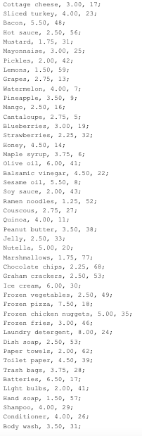

userData.txt

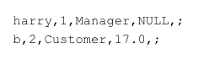

REST OF CODE WITH ALL CLASSES IS ATTACHED IN A ZIP FILE ON BRIGHTSPACE